
Sample Assessment Tasks

Chemistry

ATAR Year 11

Copyright
© School Curriculum and Standards Authority, 2014
This document – apart from any third party copyright material contained in it – may be freely copied, or communicated on an intranet, for non-commercial purposes in educational institutions, provided that the School Curriculum and Standards Authority is acknowledged as the copyright owner, and that the Authority’s moral rights are not infringed.
Copying or communication for any other purpose can be done only within the terms of the Copyright Act 1968 or with prior written permission of the School Curriculum and Standards Authority. Copying or communication of any third party copyright material can be done only within the terms of the Copyright Act 1968 or with permission of the copyright owners.
Any content in this document that has been derived from the Australian Curriculum may be used under the terms of the Creative Commons Attribution-NonCommercial 3.0 Australia licence
Disclaimer
Any resources such as texts, websites and so on that may be referred to in this document are provided as examples of resources that teachers can use to support their learning programs. Their inclusion does not imply that they are mandatory or that they are the only resources relevant to the course.

Sample assessment task

Chemistry – ATAR Year 11

Task 7 – Unit 1
Assessment type: Extended response

Conditions

Period allowed for completion of the task: 3 weeks

Task weighting

5% of the school mark for this pair of units

____________________________________________________________________________________________________

Comparing fossil fuels and biofuels (47 marks)

Identify the main components (give the name and, where practical, the chemical formula) for the following fossil fuels and biofuels
- coal
- petroleum
- petrodiesel
- natural gas
- biogas
- biodiesel
- bioethanol.

Compare the energy output of these fuels on a gram and mole basis. For fuels that are a mixture, the mole comparison can be based on the most common component or a typical component of the fuel. Assume complete combustion for the comparison.

Compare the carbon dioxide produced for complete combustion of each of the fuels on a gram and mole basis. Again for mixtures use the most common component or a typical component of the fuel.

For one application of one fossil fuel and one application of one biofuel comment on the validity of assuming complete combustion in determining energy output. Explain your reason for either accepting or rejecting the assumption.

Give references for the sources you have used to get information (you must use at least three resources).

Marking key for sample assessment task 7 – Unit 1
Description | Marks
1 mark for main components of each fuel  - coal  - petroleum  - petrodiesel  - natural gas  - biogas  - biodiesel  - bioethanol | 1–7
1 mark for energy output on a gram basis for each fuel | 1–7
1 mark for energy output on a mole basis for each fuel | 1–7
1 mark for CO₂ output on a gram basis for each fuel | 1–7
1 mark for CO₂ output on a mole basis for each fuel | 1–7
Discussion of application of fossil fuel (and recognition that complete combustion is unlikely)  - description of application  - discussion of fuel to oxygen ratio in the application  - statement about validity of assuming complete combustion for energy and CO₂ outputs (linked to discussion about fuel to oxygen ratio) | 1–4
Discussion of application of biofuel (and recognition that complete combustion is unlikely)  - description of application  - discussion of fuel to oxygen ratio in the application  - statement about validity of assuming complete combustion for energy and CO₂ outputs (linked to discussion about fuel to oxygen ratio) | 1–4
References  - at least three sources – 1 mark for each source up to 3 marks  - 1 mark for referencing style that enables verification | 1–4
Total | /47

Sample assessment task

Chemistry – ATAR Year 11

Task 8 – Unit 1
Assessment type: Test

Conditions

Time for the task: 50 minutes

Task weighting

2% of the school mark for this pair of units

____________________________________________________________________________________________________

Organic Chemistry Test

Structure of the test:

Section | Suggested  working time | Number of questions | Marks
ONE  Multiple-choice | 10 minutes | 10 | 10
TWO  Written answers | 40 minutes | 7 | 30

DO NOT OPEN THE TEST UNTIL INSTRUCTED TO DO SO

Section 1: Multiple-choice questions 10 Marks

1. Which one of the following is not a reason for carbon to be able to form large numbers of compounds?

(a) The ability of carbon atoms to form four covalent bonds.

(b) The ability of carbon atoms to bond to each other in covalent network structures.

(c) The ability of carbon atoms to form multiple (double and triple) covalent bonds.

(d) The ability of carbon atoms to bond with each other to form long stable chains.

2. A hydrocarbon with the formula C₆H₁₂ could be what type of compound?

(a) a straight chain alkane

(b) a branched chain alkane

(c) an alkene

(d) an aromatic hydrocarbon

3. Which one of the following molecules contains a double bond?

(a) (CH₃)₂CHCH₃

(b) (CH₃)₃CCH₂CH₃

(c) CH₃CH₂C(CH₃)₂CH₃

(d) (CH₃)₂CCHCH₃

4. Which one of the following hydrocarbons is unsaturated?

(a) CH₄

(b) C₇H₁₆

(c) C₄H₁₀

(d) C₃H₆

5. Which one of the following sets of formulae contains only one saturated hydrocarbon?

(a) C₂H₆, C₃H₆, C₄H₈

(b) C₃H₆, C₄H₈, C₆H₁₂

(c) C₂H₆, C₃H₆, C₈H₁₈

(d) CH₄, C₂H₆, C₆H₁₄

6. Which one of the following statements about the benzene molecule is false?

- Benzene has the molecular formula C₆H₆.
- Benzene has a planar (flat) structure with all bond angles 120°.
- Benzene will react with Br₂ in an addition reaction similar to addition of Br₂ to alkenes.
- The pi (double bond) electrons in benzene are delocalised.

7. Which one of the following is the correct equation for the complete combustion of butane?

(a) 2 C₄H₁₀ + 13 O₂ → 8 CO₂ + 10 H₂O

(b) 2 C₄H₁₀ + 10 O₂ → 8 CO + 10 H₂O

(c) C₄H₈ + 6 O₂ → 4 CO₂ + 4 H₂O

(d) C₄H₈ + 4 O₂ → 4 CO + 4 H₂O

8. Which one of the following compounds readily undergoes addition reactions?

(a) ethane (C₂H₆)

(b) ethene (C₂H₄)

(c) methylbenzene (C₇H₈)

(d) chloromethane (CH₃C)

9. When pent-2-ene is reacted with chlorine water, the most likely product is

(a) 2,2-dichloropentane.

(b) 2,3-dichloropentene.

(c) 2,3-dichloropentane.

(d) 1,2-dichloropentane.

Consider the reaction of benzene shown below to answer question 10.

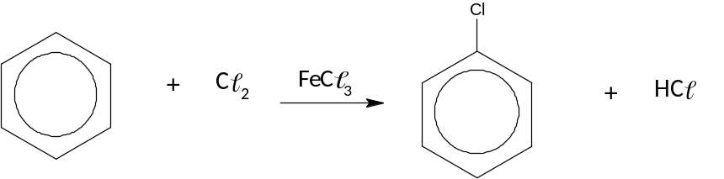

10. This type of reaction is known as

(a) combustion.

(b) redox.

(c) addition.

(d) substitution.

Section 2: Written answers 30 Marks

1. Complete the following table by writing the IUPAC name of the compound or drawing the structure as appropriate. Show all hydrogen atoms for structures you draw. (4 marks)

IUPAC Name | Structure
(1 mark) | 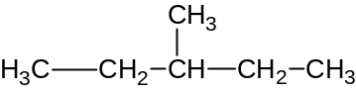
3-chloro-2-methylhexane | (1 mark)
(1 mark) | 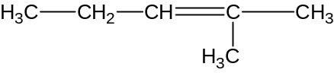
2,3-dimethyloct-4-ene | (1 mark)

2. Complete the following reaction equations by writing the formula for the missing molecule in the space provided. (3 marks)
hv

(a) CH₃CH₃ + C₂ CH₃CH₂C +

hv

(b) CH₃Br     + Br₂ + HBr

(c) + HBr      CH₃CH₂CHBrCH₃

3. Write balanced chemical equations for the following reactions. Structural formulae can be used to write the equations. (6 marks)

(a) Butane reacts with chlorine gas in the presence of ultraviolet (UV) light.

(b) Octane burns in a plentiful supply of oxygen.

(c) Pent-2-ene reacts with bromine gas.

4. It is possible for straight chain and branched alkanes with the molecular formula C₅H₁₂ to exist. Draw and name the structural formulae of the 3 possible alkanes with this molecular formula. Show all hydrogen atoms in your structures. (6 marks)

(a)

name: _______________________

(b)

name: ________________________

(c)

name: __________________________

5. For the following pair of compounds describe a chemical test that could be used to distinguish between them. Include the distinguishing observation in your answer. (4 marks)

CH₃CH₂CH₂CH₂CH₃ and CH₃—CH=CH—CH₂—CH₃

Test:

Distinguishing observation:

6. The structure of benzene is represented by two 6-membered rings with double bonds shown in alternate positions and a double headed arrow between the two 6-membered rings (1) or by a single 6-membered ring with a circle in the centre (2).

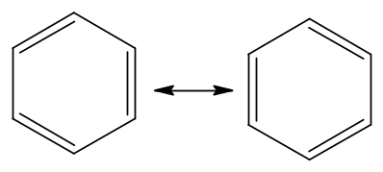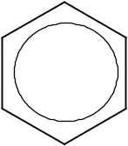
OR

1 2

Explain why benzene is represented by structure 1 or 2 rather than a single 6-membered ring with three single bonds and three double bonds. (3 marks)

7. Propane gas is used in gas cylinders for barbeques. The equation for combustion of propane is shown below with its enthalpy change.

C₃H₈(g) + 5 O₂(g) 3 CO₂(g) + 4 H₂O(g) + 2202 kJ

If a gas cylinder contains 45.0 kg of propane, how much energy (in kilojoules) can be produced by the combustion of the gas? (4 marks)

Marking key for sample assessment task 8 – Unit 1

Section 1: Multiple-choice 10 marks

Question | Correct  response
1 | b
2 | c
3 | d
4 | d
5 | a
6 | c
7 | a
8 | b
9 | c
10 | d

Section 2: Written answers 30 marks

1. Complete the following table by writing the IUPAC name of the compound or drawing the structure as appropriate. Show all hydrogen atoms for structures you draw. (4 marks)

IUPAC Name | Structure
3-methylpentane
(1 mark)
3-chloro-2-methylhexane | 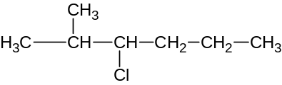 (1 mark)
2-methylpent-2-ene
(accept 2-methyl-2-pentene)
(1 mark)
2,3-dimethyloct-4-ene | 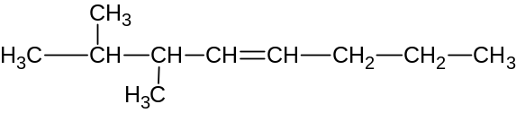  (1 mark)

2. Complete the following reaction equations by writing the formula for the missing molecule in the space provided. (3 marks)
hv
HC

(a) CH₃CH₃ + C₂ CH₃CH₂C +

hv
CH₂Br₂

(b) CH₃Br     + Br₂ + HBr

CH₃CHCHCH₃
OR
CH₃CH₂CHCH₂

(c) + HBr      CH₃CH₂CHBrCH₃

Description | Marks
1 mark for each correct molecule | 3

3. Write balanced chemical equations for the following reactions. Structural formulae can be used to write the equations. (6 marks)

(a) Butane reacts with chlorine gas in the presence of ultraviolet (UV) light.
hv

CH₃CH₂CH₂CH₃ + C₂ CH₃CH₂CH₂CH₂C + HC

Accept any chlorobutane

Description | Marks
1 mark for correct formulae for reactants | 1
1 mark for correct formulae for product(s) | 1

(b) Octane burns in a plentiful supply of oxygen.

2 C₈H₁₈ + 25 O₂ 16 CO₂ + 18 H₂O

Description | Marks
1 mark for correct formulae for reactants and products | 1
1 mark for balancing | 1

(c) Pent-2-ene reacts with bromine gas.

CH₃CHCHCH₂CH₃ + Br₂ CH₃CHBrCHBrCH₂CH₃

Description | Marks
1 mark for correct formulae for reactants | 1
1 mark for correct formula for product | 1

4. It is possible for straight chain and branched alkanes with the molecular formula C₅H₁₂ to exist. Draw and name the structural formulae of 3 possible alkanes with this molecular formula. Show all hydrogen atoms in your structures. (6 marks)

(a)

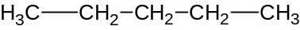

name: pentane

(b)

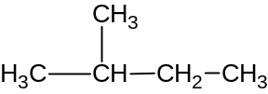

name: methylbutane (accept 2-methylbutane)

(c)

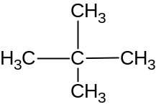

name: 2,2-dimethylpropane

Description | Marks
1 mark for each correct structure | 3
1 mark for each IUPAC name | 3

5. For the following pair of compounds describe a chemical test that could be used to distinguish between them. Include the distinguishing observation in your answer. (4 marks)

CH₃CH₂CH₂CH₂CH₃ and CH₃—CH=CH—CH₂—CH₃

Test:
Shake each hydrocarbon with about 10 drops of bromine water in the absence of UV light (or in dark). Quantity of bromine water used should not be in excess. (excess Br₂ water will mean orange colour will remain even if reaction occurs)

Distinguishing observation:

The bromine water will decolourise rapidly when shaken with the alkene.
The bromine water will not decolourise (or very slowly decolourise) with the alkane.

Description | Marks
Recognition that hydrocarbons are shaken with bromine water  (recognition of quantity not needed to get mark) | 1
Recognition that reaction is done in absence of UV light | 1
Recognition that alkene decolourises bromine water | 1
Recognition that alkane does not decolourise bromine water | 1

6. The structure of benzene is represented by two 6-membered rings with double bonds shown in alternate positions and a double headed arrow between the two 6-membered rings (1) or by a single 6-membered ring with a circle in the centre (2).

OR

1 2

Explain why benzene is represented by structure 1 or 2 rather than a 6-membered ring with three single bonds and three double bonds. (3 marks)

Description | Marks
Recognition that benzene does not have 3 single bonds and 3 double bonds | 1
Recognition that the C to C bonds are all the same with same bond length intermediate of the typical C to C single bond and C to C double bond | 1
Recognition that benzene has 6 delocalized electrons | 1

7. Propane gas is used in gas cylinders for barbeques. The equation for combustion of propane is shown below with its enthalpy change.

C₃H₈(g) + 5 O₂(g) 3 CO₂(g) + 4 H₂O(g) + 2202 kJ

If a gas cylinder contains 45.0 kg of propane, how much energy (in kilojoules) can be produced by the combustion of the gas? (4 marks)

Description | Marks
M(C₃H₈) = 44.094 g mol^{–1} | 1
m(C₃H₈) = 45.0 kg = 45000 g | 1
n(C₃H₈) = 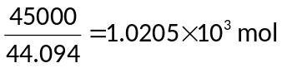 | 1
Energy = 2202 × 1.0205 × 10³ = 2.25 × 10⁶ kJ | 1

Sample assessment task

Chemistry – ATAR Year 11

Task 17 – Unit 2
Assessment type: Practical investigation

Conditions

Period allowed for completion of the task: 1.5 weeks

Task weighting

5% of the school mark for this pair of units

____________________________________________________________________________________________________

Determine which acid is the most reactive when reacted with metal carbonates. (24 marks)
The effect of acid rain on statues made from calcium carbonate is well documented.
The aim of this investigation is to determine if there is any difference in the reaction rate of different acids with metal carbonates.
Task description
- Research what ‘reaction rate’ means and how you could measure it in a school laboratory (Suggestions: rate of mass loss during evolution of carbon dioxide, rate of evolution of carbon dioxide).
- Brainstorm or discuss what ‘most reactive’ might mean. For example, it may mean the fastest reaction with another agent. Write down what you have decided ‘most reactive’ means and explain why you chose that way to define it.
- Design a way to measure the reaction rates of the samples provided. Write a detailed description of your design, including the equipment and acids you intend to use, the dependent and independent variables, the measurements or observations you intend to make and how you propose to process your data.
- Carry out your experimental work in your group.
- Process the data on an individual basis. Show all working.
- Write your report. This should include an introduction describing what ‘reaction rate’ and ‘most reactive’ mean; details of experimental designs; all raw measurements, calculations and observations in the ‘Results’ section; your conclusions; and evidence of the ways you minimised errors and uncertainties.

Time plan
Step | Day | Step | In-class/homework
1 | 1 | Submit definition of ‘most reactive’ | 20 min brainstorm/discussion
2 | 2 | Group discussion of research ideas followed by individual submission of research design | Entire period
3 | 3 | Carry out procedure and collect data (group) | Entire period
3 | 4 | Carry out procedure and collect data (group) | Entire period
4 | 5 | Process data (individual) | Entire period and homework
5 | 6 | Submit report (individual) | Entire period

Marking key for sample assessment task 17 – Unit 2
Description | Marks
Research and submit research design  - evidence of individual research  - identification of variables  - viable experimental design | 1  1  1
Subtotal | /3
Carry out procedure and collect data  - selection of appropriate equipment  - safety precautions used during procedure  - all raw measurements recorded in an appropriate format  - evidence of fair testing | 1  1  1–2  1
Subtotal | /5
Processing data  - calculations and observations  - evaluation of data  - conclusions | 1–2  1–2  1–2
Subtotal | /6
Submit report  - information from research in introduction  - details of experimental design  - evidence of the ways you minimised errors and uncertainties  - report presented using appropriate format  - use of scientific terminology as appropriate | 1–2  1–2  1–2  1–2  1–2
Subtotal | /10
Total | /24

